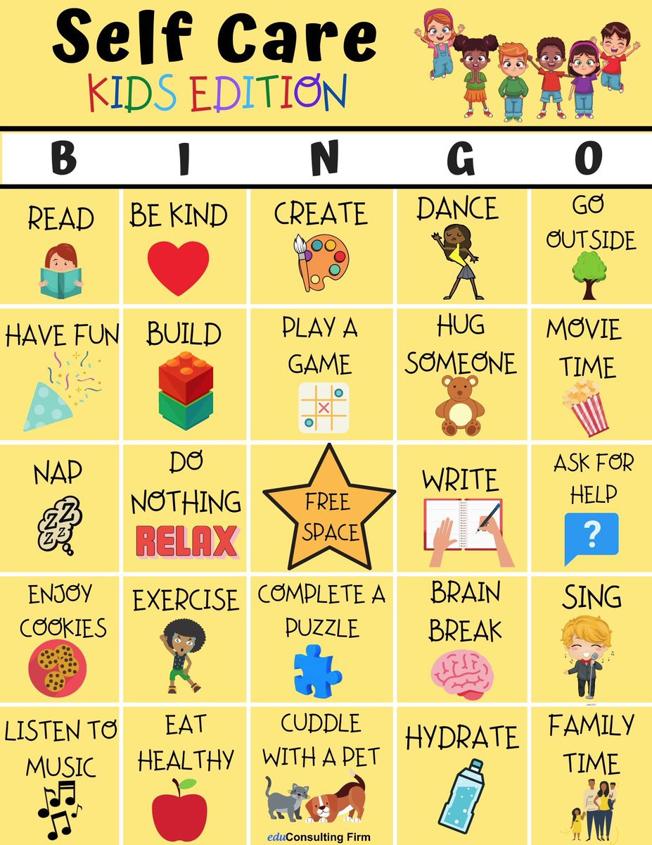

*This chart can and should be used for both children and parents. We understand how difficult this time is and we want to encourage both parents and students alike to take care of yourselves. Children often show signs of needing self-care activities by being overly energetic, having more tantrums or meltdowns than usual, or showing an overall difference in their normal behavior. In that case, present children with this by printing it out and hanging in your home or simply using your phone. We encourage parents to also use this and to know it is not only okay to take a break and step back but it is also healthy to do so!

**Activity**: Use this chart as a simple choice chart for your child to choose when they show signs of needing a break. Allow your child to choose one of these activities and snap a photo of them while they are doing it. Parents, feel free to jump in and snap a photo as well!